THE A-TEAM  
 Meeting Future Global Software Needs Today

456 Stewart Street | Tampa, Florida | 12345

March 12, 2017

Wayne Pollock, VP Marketing

Example Corporation

123 Main Street

Tampa, FL 12345

RE: RFP #1074-2 Voice Mail System

Dear Mr. Pollock,

We look forward to working with Example Corporation and supporting your efforts to improve your employee voice messaging system. We offer exemplary integrated Consumer Relationship Management (CRM), Just-In-Time (JIT) Inventory management, and training and support services. We are confident that we can meet the challenges ahead, and stand ready to partner with you in delivering an effective voice messaging support solution.

If you have questions on this proposal, feel free to contact me at your convenience. We will be in touch with you next week to arrange a follow-up conversation on the proposal.

Thank you for your consideration,

Sharon Tender

Sr. Testing Software Engineer

Proposal Attached

The A-Team

www.a-team.com

March 12, 2017

RFP #1074-2 Voice Mail System

VOICE MAIL SOFTWARE PROPOSAL

The A-Team Proposal

The A-Team  
Voice Mail Software Proposal

For Example Corporation, Tampa, Florida

Contact for Example Corp:

Wayne Pollock, VP Marketing

wpollock@example.com

Proposal Delivery to:

Betty Boop, VP Technologies

bboop@example.com

123 Main Street

Tampa, FL 12345

Contact for The A-Team:

Sharon Tender, Sr. Testing Software Engineer

sharon.tender@The a-team.com

456 Stewart Street

Tampa, FL 12345

Ph 456-125-8998

FAX 456-123-9889

www.a-team.com

Contents

Overview 5

Basic Voice Mail Requirements 5

Proposal 6

The Options 6

Hosting 6

Execution Timeline 7

Supplied Material 7

Pricing 8

Terms and conditions. 8

Qualifications 9

References 9

Organizational Capacity 9

Company profile 9

Staff Devoted to Example Corporation 10

Team 10

Project Management Process 10

Percent of total revenue derived from voicemail/PBX developments 10

Planned IPOs, mergers or acquisitions. 10

Hardware/Software vendor partnerships 10

Testing and Support 11

Correspondence with our client 12

Appendix A: Use-Case scenerios 14

Use Case - Administrator 14

Administrator Use Triggers 14

Pre-Conditions 14

Post-Conditions 14

Normal Flow for Admin 14

Use Case - Employee 14

Employee Use Triggers 14

Pre-Conditions 14

Post-Conditions 14

Normal Flow for Creating Outgoing Voice Message 14

Normal Flow for Listening and Forwarding Voice Message 15

Use Case - Caller 15

Triggers 15

Pre-Conditions 15

Post-Conditions 15

Normal Flow for Caller 15

Appendix B: Uml diagram 16

Appendix C: Functional specifications 17

Appendix D: Staff Organizational Chart 19

APPENDIX E: Service-level agreement (SLA) 20

Table of Contents: 20

Agreement Overview 21

Goals and Objectives 21

Stakeholders 21

Periodic Review 21

Service Agreement 22

Service Management 22

# Overview

The A-Team is pleased to submit this proposal for voice messaging software to Example Corporation. We will strive to present a clear and concise description of our plan to help you reach and exceed your goals to update your current voice messaging system.

## Basic Voice Mail Requirements

Develop a voice mail system with the following capabilities: *See Appendix A for Use-Case Scenarios.*

* Need #1: Support password security features
  + Ability to create and change passcodes
* Need #2: Support incoming voice messages
  + Play incoming voice messages
  + Delete incoming voice messages
* Need #3: Support User Greeting for voice messages
  + Record outgoing message
  + Delete outgoing message
  + Update outgoing message
* Need #5: Create Administrator voice messaging support
  + One UI/Portal
  + Support password security features for Admins
  + Activate voice mailbox
  + Deactivate voice mailbox
  + Access to employee voice mailbox
    - Play and copy selected messages
* Need #6: Create non-volatile persistent storage through CRUD
  + Create, Read, Update and Delete voice mail data saved to a server
* Need #7 Training
  + Administrators – onsite training
  + Employees – manuals only

# Proposal

## The Options

In addition to the Basic Voice Mail Requirements listed above, The A-Team proposes the following recommendations for us to provide the top-notch product you deserve.

* Package #1: Basic Voice Mail Service
  + This service covers all your basic needs as described in the RFP
* Package #2: Caller Enhanced Solution
  + Includes all the features in Package #1
  + Feature #1: ability to play back messages
  + Feature #2: ability to re-record messages
  + Feature #3: ability to delete or end call without leaving a message
  + Feature #2: ability to redirect responses to alternate phones or extensions
* Package #3: Executive Solution for Enhancing Service to your Clients
  + Include all the features in both Package #1 and #2
    - Includes up to 50 of your executives and sales personnel
  + Feature #1: ability to access messages via UI/portal
    - In or out of office to maximize your employees’ access to clients
  + Feature #2: ability to send and receive text messages (through the portal only)
  + Feature #3: ability for call redirect
  + Feature #4: ability for video-teleconference via the portal site
  + Feature #5: ability to use Teletype for the hearing impaired
  + Feature #6: ability for the user to forward phone calls to their cell phone

## Hosting

We team up with GitDaddy for all our customers that require server hosting. GitDaddy has proven to be a reliable partner who has experience hosting in over 5 nations with over 20,000 sq. ft. of dedicated server space spread out into 3 states and 2 countries to provide redundancy for their clients.

* + GitDaddy
  + 125 Central Ave.
  + Phoenix, AZ 82345
  + 526-564-4568

GitDaddy’s commitment to its clients:

* Back-up timeline: Every Sunday morning at 2am
  + Additional back-ups are performed based on potential weather events
* With 5 locations in 2 countries, we do not experience downtime
* We perform runtime software updates monthly
* We have tech support for 6 different languages available 8am eastern time to 5pm western time. Emergency support 24/7
* Our server locations are housed in unmarked buildings. Employees must pass a level 3 security background check. Our call center technicians must pass level 1 security background check
* We maintain high-speed direct connection to the internet with a firewall at each location
* Based on < 45,000 MB of transfer data per hour

## Execution Timeline

Key project dates are outlined below. Dates are best-guess estimates and are subject to change until a contract is executed.

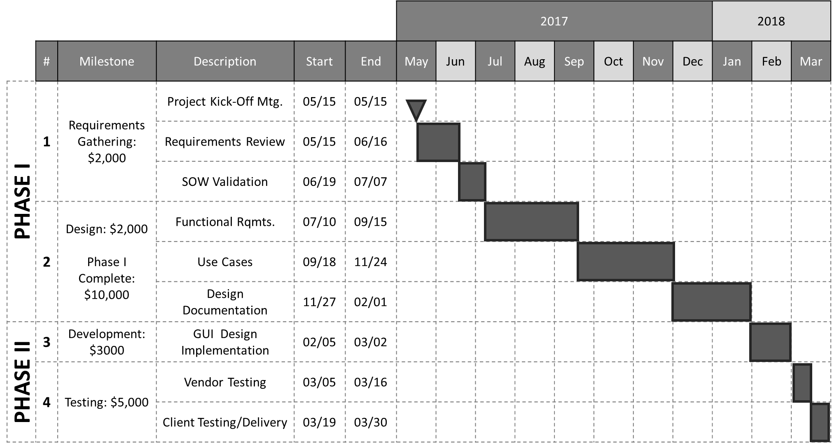

## Supplied Material

For The A-Team to meet project milestones, this material must be supplied on schedule. The due date included in the following table represent our best guess based on current proposed project dates:

|  |  |
| --- | --- |
| Materials to be supplied by Example Corporation | Due Date* |
| Phones (need this to determine the technology to use) | 07/01/17 |

*We cannot be responsible for cost overruns caused by client’s failure to deliver materials by agreed-upon due dates.

# Pricing

The following table details the pricing for delivery of the services outlined in this proposal. This pricing is valid for 30 days from the date of this proposal:

|  |  |
| --- | --- |
| Package #1: Basic Voicemail System Cost | Price |
| Includes Basic US Minimum Standard Security |  |
| Includes Basic 4-digit, Non-Expiring Passcode for Each User |  |
| Includes One Admin UI/Portal |  |
| Total Package #1 Basic Voicemail System | $25,000.00 |
| **Package #2: Caller Enhanced Solution** | |
| Includes Package #1 |  |
| Total Package #2 | 32,000.00 |
| **Package #3: Executive Solution for Enhancing Service to your Clients** |  |
| Includes Package #1 & #2 |  |
| Total Package #3 | 40,000.00 |
| **Hosting Package utilizing GitDaddy** |  |
| Total Hosting (Pricing is for hosting alone outside of the packages) | 5,000/yearly |
|  |  |

*Disclaimer: The prices listed in the preceding table are an estimate for the services discussed. This summary is not a warranty of final price. Estimates are subject to change if project specifications are changed or costs for outsourced services change before a contract is executed.*

## Terms and conditions.

The prices listed in this proposal are an estimate for the services discussed. This summary is not a warranty of final price. Estimates are subject to change if project specifications are changed or costs for outsourced services change before a contract is executed.

# Qualifications

The A-Team has continually proven to be an industry leader for communication software development.

## References

Below are three examples of our voicemail system innovations and reference information:

* Sims’s Sunglass Shack
  + Developed unique communication system where phones with a display interface are attached to each employee wrists so they never miss a potential client. The employee taps a button on the wrist screen to answer call then communicate with caller using Blue-tooth ear-bud. The device automatically hangs up the call when the hand extends to their side. The device would pulse lightly if the employee had a voice message.
  + John Sims, CEO
  + 123-456-7891
* Ray Jenkins
  + Ray is def so we developed a system that alerted him to phone calls via a light in his glasses. When he answered the call, his glasses shaded a bit so he could read the caller’s phone number. With a hand-wave across in front of him, the call was answered. As the caller spoke, the words were typed across his lenses. He replied to calls by typing on a keyboard wrapped around his lower arm. The keyboard was made for one-handed typing and was immediately read by the computer to the caller.
  + Ray Jenkins
  + 789-456-1236
* Mars Travel Agency
  + Our client needed a way to reach their space travelers on Mars. The A-Team developed a new innovated way to send a transmission utilizing the speed of light. The message was encapsulated into a light photon and sent in a laser beam to an Earth satellite, a high powered laser beam was then sent to the Mars satellite which in turn sent the beam to the traveler on the planet. Message speeds were between 5 and 10 minutes depending planet positions.
  + Buzz Alldrone
  + 456-897-4523

## Organizational Capacity

* 45,000 sq. ft. warehouse for equipment, located in Riverview, FL
* 5,000 sq. ft. office space for employees Located in Tampa, FL
* 3,000 employees

## Company profile

* 15 years in business
* Specialize in Communications Software
* Staff profile:
  + 2,500 full time Staff
  + 250 part-time
  + 100 interns
  + 150 contract

## Staff Devoted to Example Corporation

* 1% of our development staff will be devoted to project
* Staff Organizational Chart is in Appendix D

## Team

* Flavio Aquino, Sr. Data Integration Software Engineer
  + Roll: Implement Design
  + 23 yrs. experience designing database design applications for Fortune 500 companies across the North and South American continents
* Sharon Tender, Sr. Testing Software Engineer
  + Roll: Test Software
  + 21 yrs. experience performing testing applications and implementing TDD for AT&T, Verizon and Brighthouse communications
* Frank Castillo, Sr. Full Stack Software Engineer
  + Roll: Design Software
  + 28 yrs. experience designing automated voice activated systems for NASA’s space communication division

## Project Management Process

* We implement an Agile work philosophy.

## Percent of total revenue derived from voicemail/PBX developments

* 30%

## Planned IPOs, mergers or acquisitions.

* None

## Hardware/Software vendor partnerships

* We produce everything in-house to have total quality control of our software

## Testing and Support

* We provide all testing prior, during, and post coding
* We provide training to administrators and support up to 1 year of delivering final product

# Correspondence with our client

To the A-Team development group:  
  
Thank you for contacting our support team. The responses  
from the project lead are below.  
  
On 4/28/2017 8:52 PM, Sharon Tender wrote:

Dear Mr. Pollock,

We are working on a proposal for your Voice Mail System RFP and we have a few questions.

1. Do you want the Administrators to access the phone system through a UI/portal

or only through the telephone itself?

For highest security, through a UI portal only.

2. If the Admin have control using a UI/portal, do you want your employees to have

access to their own voice mail through the UI/portal also?

No, regular access should be from a phone only.

3. Do/will your phones have a digital interface for displaying caller ID?

Yes.

4. Will the users be expected to change their passcode on a regular basis?

Passwords should be check for poor quality and not allow at all if they fail a check. After that, there is no reason to expire passwords. In fact, current U.S. NIST standards recommend not expiring passwords. Yes, users can select their own passwords as long as they pass the checks. Specific checks are likely to change over time, so these must be updatable without recompiling the system.

5. What level of security are you requiring?

The messages should be protected to the full extent required by law. We need to meet U.S. and state law on this.

6. Will the default greeting message need to be in a language other than English?

Good question! But this location of Example Corp. is only local, and English only is fine. Out of curiosity, what would be the cost of having one or two additional languages available?

7. What kind of options do you want the callers to have?

a) ability to play-back the message they left

b) ability to re-record a message

c) ability to delete and end call without leaving a message

d) ability to input another extension to be re-directed to another voice mail

e) ability to send a text message (then re-directed and emailed to employee)

f) ability to use Teletype for the hearing impaired

All those sound worth-while. Please make a proposes which includes prices for these options.

8. How long do you wish to archive voice mails?

We have deferred this question to our attorney, since we are unsure of the legal requirements. For now, assume all messages must be archived, even if deleted, for a period of time determined by the administrator.

9. What is the maximum amount of messages that can be saved per user?

In a user's inbox, 30-50 should be fine. If it makes a difference in your price, we could live with fewer. Additionally, messages need to be archived. Storage will be needed. Our support team estimates out employees receive an average of 0-3 messages a day. Legal requirements will dictate the retention period, so assuming a year retention with no deletions, about 1,000 message per person.

Thank you for your input.

Sincerely,

Sharon Tender

Thank you for your interest. We look forward to receiving your  
proposal.  
  
--  
Wayne Pollock, VP marketing  
Example Corp.  
Tampa Florida USA

# Appendix A: Use-Case scenerios

## Use Case - Administrator

### Administrator Use Triggers

* Need to Delete voicemail box
* Need to Create a voicemail box
* Need to Create a passcode
* Need to Change/Reset a passcode
* Need to Access a voicemail box
* Need to Forward a voicemail box

### Pre-Conditions

* Must have administrative rights
* Needs a passcode
* Must use UI/Portal

### Post-Conditions

* Changes must be persistent

### Normal Flow for Admin

1. Navigates to portal through browser window
2. Logs into portal with Admin credentials/password
3. System verifies access
4. Admin updates voice mail system
   1. Create passcode for new employee
   2. Delete voice mail box for old employee
      1. Listens to old employee messages to determine if it needs forwarding or archived
      2. Forward old employee messages to another employee
      3. Disables old employee voice mail box
      4. Reset the old employee’s phone voice message passcode
      5. Reset the old employee outgoing voice message to default
   3. Reset an existing employee passcode
5. Exits portal

## Use Case - Employee

### Employee Use Triggers

* Need to Create outgoing voice message
* Need to Listen to voice mail
* Need to Delete voice mail
* Need to Revert to default outgoing voice message
* Need to Forward a voice mail

### Pre-Conditions

* Employee voice mail box must be initiated by Admin
* Employee must have voice mail rights
* Needs a passcode

### Post-Conditions

* Changes must be persistent

### Normal Flow for Creating Outgoing Voice Message

1. Pick up phone and select voice mail access button
2. Enter passcode when prompted
3. Listen to list of available options
   1. 1 to create outgoing voice message
   2. 2 to listen to voice mail
   3. 0 to exit system
4. Select “1” for creating outgoing voice message
5. Speak message after the tone, press # when finished
6. Listen to available options
   1. 1 to accept
   2. 2 to re-record
   3. 3 to use default
7. Select 1 to accept
8. Listen to list of available options
   1. 1 to create outgoing voice message
   2. 2 to listen to voice mail
   3. 0 to exit system
9. Select “0” or hang-up to exit system

### Normal Flow for Listening and Forwarding Voice Message

1. Pick up phone and select voice mail access button
2. Enter passcode when prompted
3. Listen to list of available options
   1. 1 to create outgoing voice message
   2. 2 to listen to voice mail
   3. 0 to exit system
4. Select “2” to listen to voice message
5. After message listen to available options
   1. 1 to delete message
   2. 2 to save message
   3. 3 to forward message
   4. 0 to exit, or hang up - message is automatically saved
6. Select “3” to forward message
7. Listen to prompt for instruction to enter extension:
   1. Enter extension
   2. Press # for more options – takes user to main
8. Select “0” or hang-up to exit system

## Use Case - Caller

### Triggers

* After X number of rings, voice mail is initiated

### Pre-Conditions

* Voice mail box must be initiated by Admin

### Post-Conditions

* Voice message must be persistent

### Normal Flow for Caller

1. Caller dials number of employee
2. Employee does not pick up phone within X number of rings
3. Employee outgoing voice message plays
4. Standard voice message system gives instructions
   1. Wait till tone then enter message
   2. Enter # after leaving message, or hang up to end the call
5. Caller waits for tone and leaves message
6. Caller enters #
7. message is saved
8. Standard voice message system issues sign-off salutations
9. Call ends

# Appendix B: Uml diagram

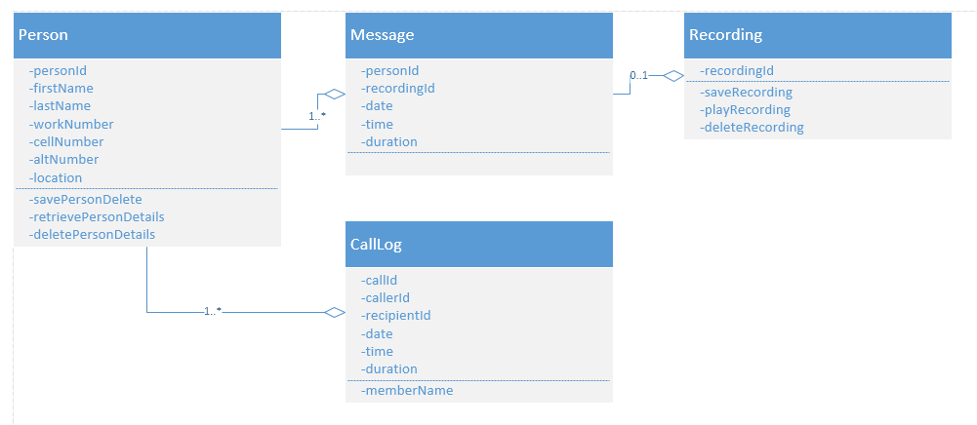

# Appendix C: Functional specifications

|  |  |  |  |  |  |
| --- | --- | --- | --- | --- | --- |
| System | Requirement | Priority | Input | Operation | Output |
| Phone System | Record messages | High | Inbound phone calls | Create voicemail | Stored voicemail |
| Play message | High | Stored voice-mail | Retrieve stored voicemail | Audio playback |
| Delete message | High | Stored voice-mail | Confirm that user wished to delete voice-mail. Delete if yes, retain if no | If yes, delete voicemail  If no, retain voicemail |
| User authentication | High | First use of phone line | Prompt user to enter passcode | Passcode-protected voicemail account |
| User authentication | High | User provides command to change/reset passcode | Prompt user to enter current passcode  Prompt user to enter new passcode with verification | Changed passcode |
| Access voicemail | High | User provides command to review voicemails | System retrieves and lists voicemails | System lists new and saved voicemails |
| Forward voicemail | High | User provides command to forward voicemail and recipient phone | System forwards voicemail to recipient | System notifies recipient that voicemail has been forwarded, and by whom |
| Configure voicemail greeting | Medium | First use of phone, or when user provides command to reset voicemail greeting | System prompts user to record greeting, plays back preliminary greeting, asks if preliminary greeting is satisfactory. If yes, store. If no, prompt user to record greeting | Stored voicemail greeting |

|  |  |  |  |  |  |
| --- | --- | --- | --- | --- | --- |
| System | Requirement | Priority | Input | Operation | Output |
| Portal | Record messages | High | Inbound phone calls | Create voicemail | Stored voicemail |
| Play message | High | Stored voice-mail | Retrieve stored voicemail | Audio playback |
| Delete message | High | Stored voice-mail | Confirm that user wished to delete voice-mail. Delete if yes, retain if no | If yes, delete voicemail  If no, retain voicemail |
| User authentication | High | Access portal based on Active Directory user credentials | Access voicemail portal | Retrieve voicemail portal |
| User authentication | High | User provides |  |  |
| User authentication | High | User provides command to change/reset passcode | Prompt user to enter current passcode  Prompt user to enter new passcode with verification | Changed passcode |

# Appendix D: Staff Organizational Chart

Staff dedicated to Voice Mail Software development

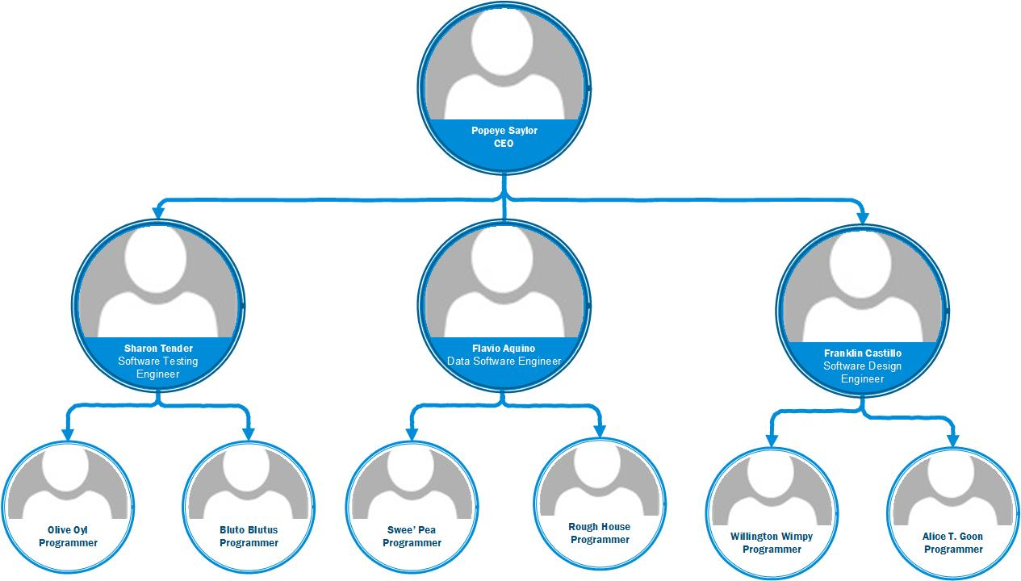

# APPENDIX E: Service-level agreement (SLA)

**Effective Date**: 05/15/17

**Document Owner**: Sharon Tender

**Document Version**:

Version Date Description Author

1.0 05/04/17 Service-Level Agreement Franklin Castillo

**Approval**:

(By signing below, all Approvers agree to all terms and conditions outlined in this Agreement)

Approvers Role Signed Approval Date

The A-Team Service Provider 05/10/17

Example Corporation Customer 05/10/17

## Table of Contents:

1. Agreement Overview 11
2. Goals and Objectives 11
3. Stakeholders 11
4. Periodic Review 11
5. Service Agreement 12
   1. Service Scope 12
   2. Customer Requirements 12
   3. Service Provider Requirements 12
   4. Service Assumptions 12
6. Service Management 12
   1. Service Availability 12
   2. Service Requests 12

## Agreement Overview

This Agreement represents a Service Level Agreement (“SLA” or “Agreement”) between the A-Team and Example Corporation for the provisioning of IT services required to deliver the Voice Mail System. This Agreement remains valid until superseded by a revised agreement mutually endorsed by the stakeholders. This Agreement outlines the parameters of all services covered as they are mutually understood by the primary stakeholders. This Agreement does not supersede current processes and procedures unless explicitly stated herein.

## Goals and Objectives

The purpose of this Agreement is to ensure that the proper elements and commitments are in place to deliver the Voice Mail System to the Example Corporation by the A-Team. The goal of this Agreement is to obtain mutual agreement for deliverable expectations between the Example Corporation and the A-Team. The objectives of this Agreement are to:

* Provide clear reference to service ownership, accountability, roles and/or responsibilities
* Present a clear, concise and measurable description of service provision to the customer
* Match perceptions of expected service provision with actual service support & delivery

## Stakeholders

The following Service Provider(s) and Customer(s) will be used as the basis of the Agreement and represent the primary stakeholders associated with this SLA:

* IT Service Provider(s): The A-Team (“Provider”)
* IT Customer(s): Example Corporation (“Customer”)

## Periodic Review

This Agreement is valid from the Effective Date outlined herein and is valid until further notice. This Agreement should be reviewed at a minimum twice per fiscal year; however, in lieu of a review during any period specified, the current Agreement will remain in effect. The Business Relationship Manager (“Document Owner”) is responsible for facilitating regular reviews of this document. Contents of this document may be amended as required, provided mutual agreement is obtained from the primary stakeholders and communicated to all affected parties. The Document Owner will incorporate all subsequent revisions and obtain mutual agreements / approvals as required.

* Business Relationship Manager: The A-Team
* Review Period: Quarterly (3 months)
* Next Review Date: 05/15/2017

## Service Agreement

The following detailed service parameters are the responsibility of the Service Provider in the ongoing support of this Agreement.

1. Service Scope
   1. The following services are covered by this Agreement:
      1. Voice Mail System development
      2. Voice Mail System upgrades
      3. Voice Mail System tech support (via remote desktop/VPN; on-site as needed)
2. Customer Requirements
   1. The Example Corporation’s responsibilities and/or requirements in support of this Agreement include:
      1. Payment for all support costs at the agreed interval
      2. Reasonable availability of customer representative(s) when resolving a service-related incident or request
3. Service Provider Requirements
   1. The A-Team’s responsibilities and/or requirements in support of this Agreement include:
      1. Meeting responsible times associated with service-related incidents
      2. Appropriate notifications to Customer for all scheduled maintenance
4. Service Assumptions
   1. Assumptions related to in-scope services and/or components include:
      1. Changes to services will be communicated and documented to all stakeholders

## Service Management

Effective support of in-scope services is a result of maintaining consistent service levels. The following sections detail service availability, monitoring of in-scope services and related components.

1. Service Availability
   1. Coverage parameters specific to the service(s) covered in this Agreement are as follows:
      1. Telephone support (normal hours): 8:00 AM to 5:00 PM EST, Monday to Friday
         1. Emergency calls outside normal business hours will be referred to 24/7 emergency number. Involves additional fees of $25/hour for first hour, $35/hour thereafter
      2. E-Mail support: monitored 8:00 AM to 5:00 PM EST, Monday to Friday
         1. E-Mails received outside of normal business hours will be replied to in the next business day
      3. On-site assistance guaranteed within 48 hours during the business week
2. Service Requests
   1. In support of services outlined in this Agreement, the A-Team will respond to service related incidents and/or requests submitted by the Customer in the following time frames:
      1. 0-8 hours (during business hours) for issues classified as High priority
      2. Within 48 hours for issues classified as Medium-to-Low priority
   2. Remote assistance will be provided in-line with the above timescales dependent on the priority of the support request.

*Academic note: referenced service-level agreement template, found in* [*http://www.slatemplate.com/ServiceLevelAgreementTemplate.pdf*](http://www.slatemplate.com/ServiceLevelAgreementTemplate.pdf)